Aptech PHP 14

HTML/CSS/JS Examination

Using some tools:

1. HTML (required)
2. CSS (required)
3. JavaScript
4. Bootstrap ^4 (required)
5. jQuery ^3 (required)
6. Font Awesome ^5

To create a News Website, some requirement:

1. At least 5 sections (containers) on webpage: header, navigation, carousel, content, footer, etc.
2. Using grid system, flex utility, align and justify of Bootstrap 4, etc.
3. Using some components of Bootstrap 4: Button, Carousel, Cards, etc.
4. Using utilities of Bootstrap 4: margin, padding, border, text, color, etc.
5. Using responsive system of Bootstrap 4 to create webpage with 2 resolutions: 0 – 767px (mobile) and >= 768px (desktop).

Optional:

1. Using jQuery to create toggle hide/show button to display some section.
2. Create child page inherit header, footer and build by yourself.
3. Using some of animation of CSS 3 or animate of jQuery.

Example:

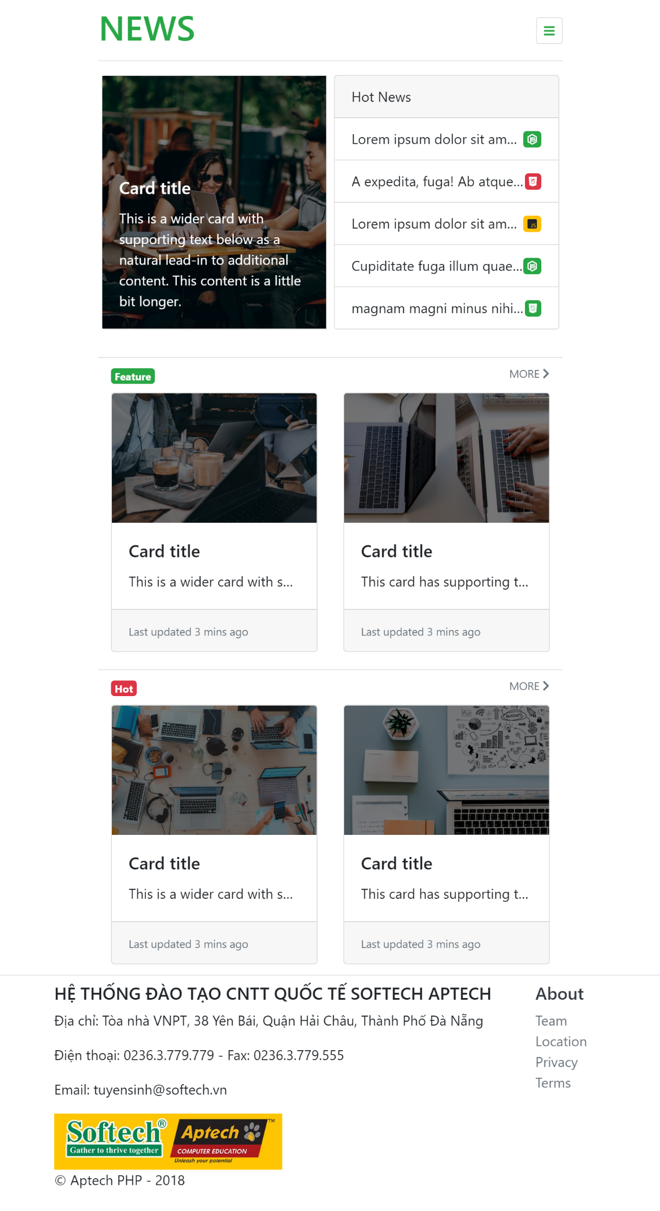

Image 1. Index Mobile (0 - 767px)

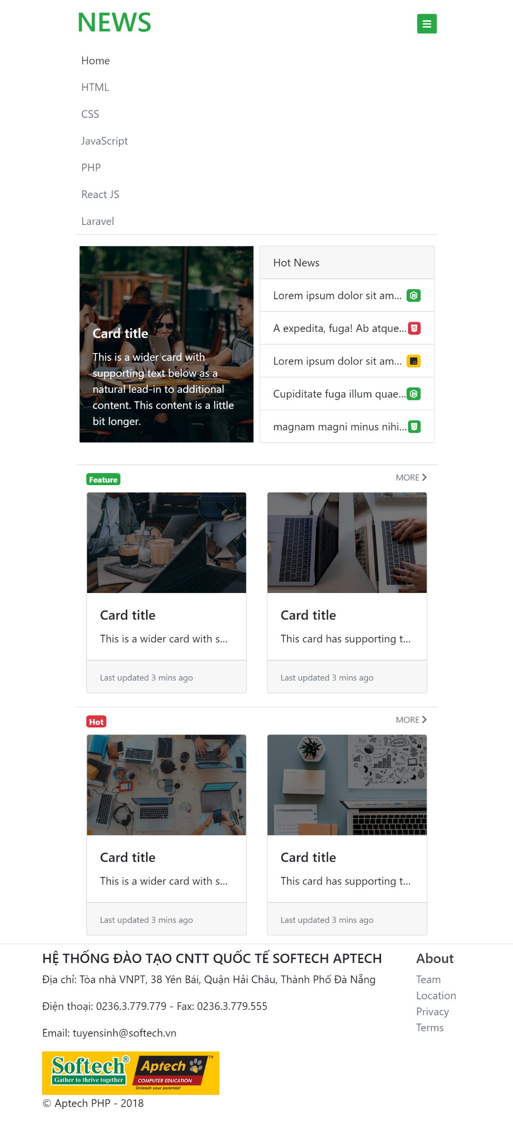

Image 2. Mobile jQuery (0-767px)

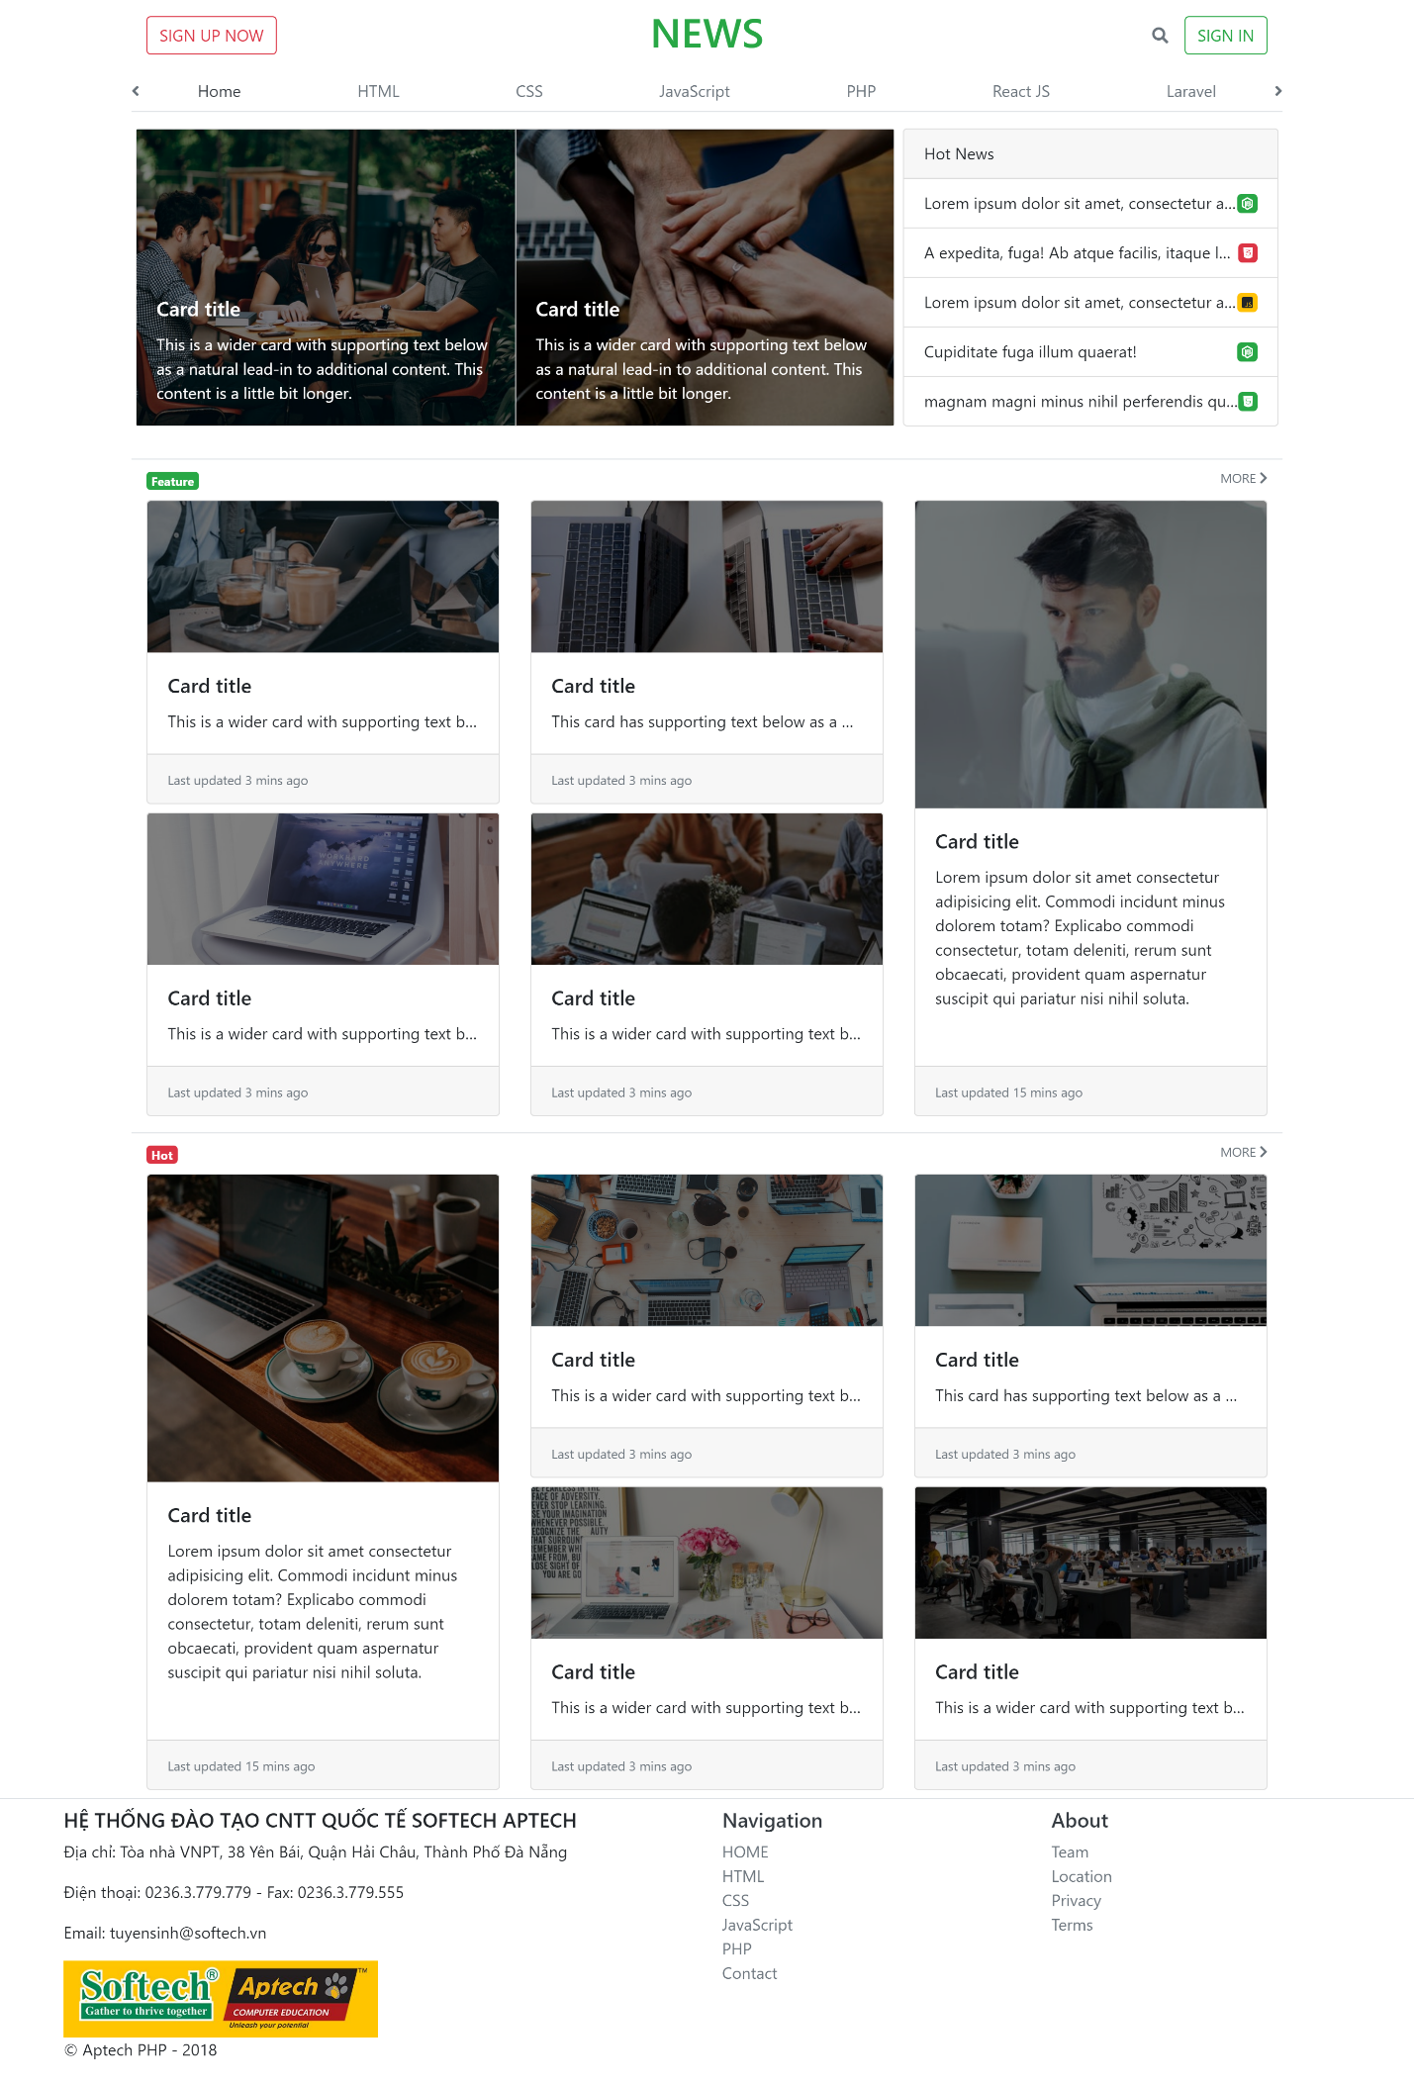

Image 3. Desktop 1440px

MOBILE :

